Steps to running linear regression in IS
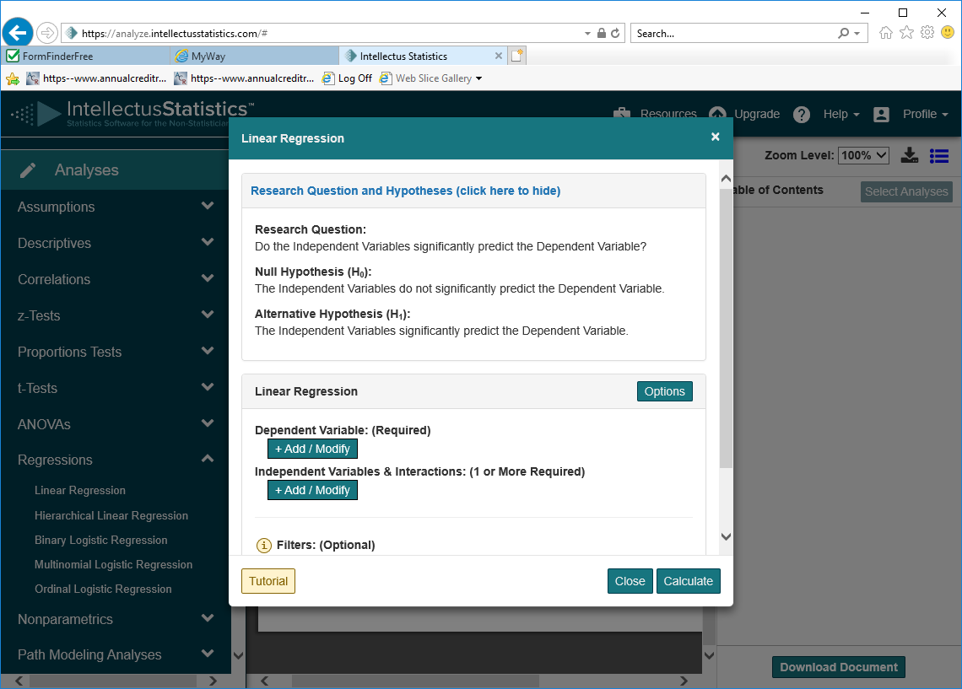

Linear regression

- Select analysis ...
- Choose Regressions and when that expands select linear regression
- Identify your variables
Know beforehand what is your DV and IV
When ready click on the +Add/Modify
Choose the variables (hit add variable button)
Check that hypothesis is correct for what you want to do.
4. if OK hit calculate
5. View the raw output view (choose button on top)
- View the results.
- View the document view to see an example of how to write up the findings of the model as well as the variable.
Extra help and information can be found using the tuturial button

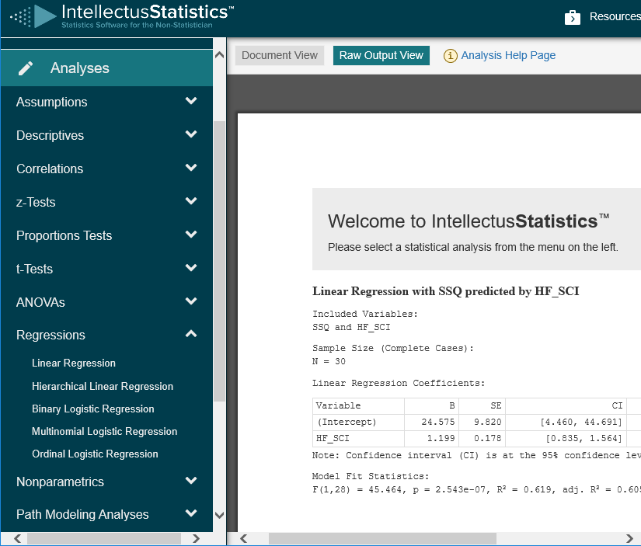
Values needed to report your results

